Supplementary Materials

Response of soil respiration to land-use change and climate warming: identifying microbial mechanisms

Loïc Nazaries ^{a,b}, William Tottey ^{b,c}, Lucinda Robinson ^{b}, Amit Khachane ª, Waleed Abu Al-Soud ^{d}, Søren Sørensen ^{d}, Brajesh K. Singh ^{a, *}

Results

Supplementary Table 1: Significance tests of the effect of land-use change on the microbial community structure.
For each ordination axis, data represent the P values obtained from the LMM analysis performed on the ordination scores of the MT-RFLP and pyrosequencing data (see Figure 1 of main text). The letters (a, b and c) show the treatments with significant difference (P values in bold) according to pairwise comparison following the Bonferroni procedure as post-hoc test (α<0.05).
 | Fungi |  | Bacteria |  | Archaea |  | Bacteria (454)
 | PC1 | PC2 | PC1 | PC2 | PC1 | PC2 | PCO1 | PCO3
Moorland | a | a | b | ab | c | a | c | b
Old Birch | a | b | b | bc | c | a | b | c
Grassland | a | a | ab | a | b | a | a | c
Pine | a | a | a | c | a | a | a | a
Variation explained | 31.2% | 19.3% | 57.4% | 16.8% | 55.5% | 32.4% | 56.3% | 8.9%
F_{prob} | 0.367 | <0.001 | 0.003 | 0.001 | <0.001 | 0.364 | <0.001 | <0.001

Supplementary Table 2: Microbial characterisation of soils from different land uses.
Phylum names are displayed in normal font while class names are in italic. Legend: the arrows ↑ and ↓ indicate an increased (or decreased) abundance of a particular phylum/class compared to other land uses, while ↔ denotes a lack of significant change. No arrow means that the phylum/class was uniquely found in the habitat(s). The P values associated are given in parenthesis. Details of the numerical values for the phylum and class abundance are presented in Figure 3 of main text and Supplementary Table 3, respectively.
 | Moorland | Old Birch | Grassland | Pine
Site differences | Acidobacteria ↑ (P<0.001) |  | Proteobacteria ↑ (P<0.001)
Site differences | Acidobacteria Acidobacteria ↑ (P<0.001) |  | Proteobacteria Alphaproteobacteria ↑ (P<0.001)
Site differences | Acidobacteria Solibacteres ↑ (P=0.002) |  | Proteobacteria Gammaproteobacteria ↑ (P=0.003)
Site differences | Planctomycetes ↑ (P=0.001) |  | Gemmatimonadetes ↑ (P<0.001)
Site differences | Planctomycetes Phycisphaerae ↑ (P=0.008) |  | Gemmatimonadetes Gemmatimonadetes ↑ (P<0.001)
Site differences | Crenarchaeota MBGA ↑ (P=0.001) |  | Gemmatimonadetes Gemm-1 ↑ (P<0.001)
Site differences | Verrucomicrobia Methylacidiphilae ↑ (P<0.001) |  | Chloroflexi ↑ (P<0.001)
Site differences |  |  | Chloroflexi Ktedonobacteria ↑ (P=0.067)
Site differences |  |  | Firmicutes ↑ (P<0.001)
Site differences |  |  | Firmicutes Bacilli ↑ (P<0.001)
Site differences |  |  | Actinobacteria Thermoleophilia ↑ (P<0.001)
Land use differences |  |  |  | AD3 ↑ (P=0.014)
Land use differences |  |  | Crenarchaeota ↓ (P=0.006)
Land use differences | Verrucomicrobia ↑ (P<0.001)
Land use differences |  |  | Acidobacteria iii1-8 ↑ (P<0.001) | Crenarcheota Thaumarchaeota ↑ (P<0.001)
Land use differences | Actinobacteria ↔ (P=0.153)
Land use differences | Actinobacteria Actinobacteria ↔ (P=0.409)
Afforestation effect |  | Acidobac. Acidobacteria-2 ↑ (P<0.001) |  | Acidobac. Acidobacteria-2 ↑ (P<0.001)
Afforestation effect |  | Verrucomicrobia Pedosphaerae ↓ (P=0.008)
Afforestation effect |  | Actinobacteria Acidimicrobiia ↓ (P=0.021)
Afforestation effect |  |  |  | Proteob. Deltaproteobacteria ↓ (P<0.001)
Afforestation effect |  |  |  | Verrucomicrobia Spartobacteria ↓ (P<0.001)

Supplementary Table 3: Most dominant classes of microorganisms detected in the soils under different land uses.
Data represent the mean percentage presence of a particular class (n=6 for Moorland and Old Birch; n=3 for Grassland and Pine). Only classes that constituted >0.5% of the total class abundance were included in the analysis, representing ~95% of class presence in all samples. For each microbial class, the letters (a, b, c) show the treatments with significant difference (P values in bold) according to pairwise comparison following the Bonferroni procedure as post-hoc test (α<0.05).
Phylum | Class | Land use |  |  |  | P value
Phylum | Class | Moorland | Old Birch | Grassland | Pine
Actinobacteria | Actinobacteria | 11.70ª | 13.47ª | 19.39ª | 13.27ª | 0.409
Acidobacteria | Acidobacteria | 13.65^{b} | 12.83^{b} | 4.37ª | 3.77ª | <0.001
Acidobacteria | Acidobacteria-2 | 7.767^{b} | 15.66^{c} | 3.03ª | 6.83^{b} | <0.001
Verrucomicrobia | [Pedosphaerae] | 15.65^{c} | 5.88^{b} | 0.86ª | 3.72^{ab} | <0.001
Acidobacteria | Solibacteres | 7.88^{b} | 8.54^{b} | 5.08ª | 4.93ª | 0.002
Proteobacteria | Alphaproteobacteria | 4.08ª | 4.66^{ab} | 7.05^{bc} | 9.90^{c} | <0.001
Planctomycetes | Phycisphaerae | 5.31^{ab} | 6.53^{b} | 3.81ª | 3.65ª | 0.008
WPS-2 | WPS-2 | 2.47ª | 5.49ª | 5.71ª | 5.54ª | 0.191
Proteobacteria | Deltaproteobacteria | 4.22^{b} | 4.19^{b} | 3.40^{b} | 1.57ª | <0.001
Proteobacteria | Gammaproteobacteria | 1.46ª | 1.76^{ab} | 6.65^{c} | 4.50^{bc} | 0.003
Verrucomicrobia | [Spartobacteria] | 0.97ª | 1.70ª | 6.40^{c} | 4.70^{b} | <0.001
Verrucomicrobia | Opitutae | 4.16^{c} | 2.14^{b} | 0.64ª | 2.59^{bc} | <0.001
Other Bacteria | Other Bacteria | 2.81ª | 2.96ª | 1.44ª | 2.44ª | 0.224
Gemmatimonadetes | Gemmatimonadetes | 0.32ª | 0.92ª | 5.28^{b} | 5.95^{b} | <0.001
Actinobacteria | Thermoleophilia | 1.29ª | 0.69ª | 4.79^{b} | 4.29^{b} | <0.001
Crenarchaeota | MBGA | 3.64ª | 2.90ª | 0.01^{b} | 0.09^{b} | 0.001
Actinobacteria | Acidimicrobiia | 2.37^{b} | 1.40ª | 1.52^{ab} | 1.50^{ab} | 0.021
Verrucomicrobia | [Methylacidiphilae] | 2.26^{b} | 1.76^{b} | 0.21ª | 0.40ª | <0.001
Gemmatimonadetes | Gemm-1 | 0.01ª | 0.08ª | 1.62^{b} | 4.66^{c} | <0.001
Planctomycetes | Planctomycetia | 0.98ª | 1.01ª | 1.45ª | 0.42ª | 0.101
Chloroflexi | Ktedonobacteria | 0.30ª | 0.58ª | 1.26ª | 1.68ª | 0.067
Proteobacteria | Betaproteobacteria | 0.56ª | 0.29ª | 1.21^{b} | 1.71^{b} | <0.001
Acidobacteria | iii1-8 | 0.05ª | 0.04ª | 3.08^{b} | 0.31ª | <0.001
Firmicutes | Bacilli | 0.02ª | 0.02ª | 2.00^{b} | 1.45^{b} | <0.001
Crenarchaeota | Thaumarchaeota | 0.04ª | 0.001ª | 0.01ª | 3.21^{b} | <0.001

Supplementary Table 4: Best-fitting regression models of soil respiration (Rs).
Out of the 13 soil abiotic properties initially investigated, only five could be retained. The PC scores of the Bacteria, Fungi and Archaea were also included in the analysis to estimate the contribution of the microbial community structure to Rs. Of all the 1023 possible OLS models, we present the model fits for the full model (that best explains variation in Rs – i.e. ΔAIC_{c} <2) and models in which some of the abiotic variables were dropped or in which some biotic variables were added. The models are ranked by increasing AIC_{c} and evidence ratio (ER) values. Each row represents a model containing the predictor variables for which the cells are filled. Variables are coloured according to the type of class they represent: orange for abiotic properties, kaki for the bacterial community structure (T-RFLP data), grey for Fungi and blue for Archaea. An indication of a model inferiority compared to the ‘best’ model is by calculating the difference in their AIC (ΔAIC_{c}). Furthermore, the Akaike weight (w_{i}) of a model is calculated relative to all the possible models thus it can be interpreted as the power of approximation of a particular model. Burnham and Anderson (2002) recommended that models with a ΔAIC_{c} of more than ten were highly unlikely to represent a plausible model to explain variation in the response variable investigated. Our analysis generated 103 models with ΔAIC_{c}<10 which constituted a ‘confidence set’ of models representing a 95% confidence interval (cumulated Akaike weights of ~0.95). Burnham and Anderson (2002) also suggested that models with a ΔAIC_{c} of less than six could not be discounted (56 models in our study) and that models with a ΔAIC_{c} of less than two (9 models in our study, cumulated AIC_{c} w_{i} ~39%) were potentially as good as the ‘best model’ (i.e. the model with the lowest AIC_{c}). Finally, the evidence ratio (ER) provides a measure of how much more likely the best model is than another model (Symonds and Moussalli, 2011). Legend: PC = Principal Component scores; AIC_{c} = corrected Akaike’s information criterion; ΔAIC_{c} = difference between the ‘best’ model and a particular model; AIC_{c} w_{i} = Akaike weight of a particular model compared to all 1023 models; ER = evidence ratio.
Model | pH | C:N ratio | Moisture | NH₄⁺ | NO₃⁻ | Bacteria |  | Fungi |  | Archaea | # of variables | R² | AIC_{c} | ΔAIC_{c} | AIC_{c} w_{i} | ER
 |  |  |  |  |  | PC1 | PC2 | PC1 | PC2 | PC2
#22 |  |  |  |  |  |  |  |  |  |  | 6 | 0.427 | -9.284 | 0.000 | 0.065 | 1.000
#7 |  |  |  |  |  |  |  |  |  |  | 7 | 0.441 | -9.053 | 0.231 | 0.058 | 1.122
#53 |  |  |  |  |  |  |  |  |  |  | 5 | 0.402 | -7.852 | 1.433 | 0.032 | 2.047
#23 |  |  |  |  |  |  |  |  |  |  | 7 | 0.430 | -7.308 | 1.977 | 0.024 | 2.687
#149 |  |  |  |  |  |  |  |  |  |  | 5 | 0.397 | -7.033 | 2.251 | 0.021 | 3.082
#28 |  |  |  |  |  |  |  |  |  |  | 8 | 0.435 | -5.627 | 3.657 | 0.010 | 6.225
#5 |  |  |  |  |  |  |  |  |  |  | 5 | 0.387 | -5.522 | 3.762 | 0.010 | 6.560
#180 |  |  |  |  |  |  |  |  |  |  | 4 | 0.347 | -2.216 | 7.068 | 0.002 | 34.261
#277 |  |  |  |  |  |  |  |  |  |  | 5 | 0.361 | -1.809 | 7.475 | 0.002 | 41.993

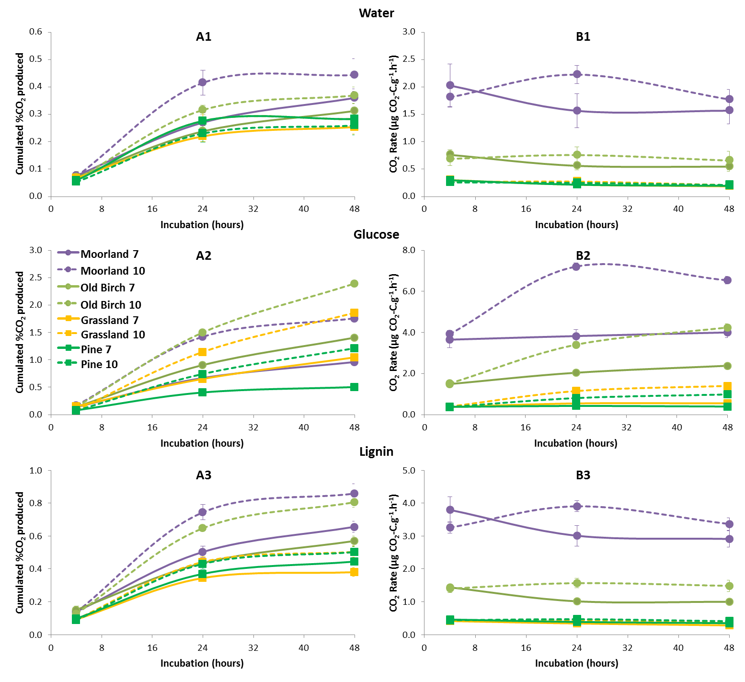
Supplementary Figure 1: Basal (1), glucose-induced (2) and lignin-induced (3) soil respiration under MAT (7°C) and MAT+3°C (10°C) over a 48-hour incubation period.
Data represent means (error bars are s.e.m.) (n=8 for Moorland and Old Birch; n=4 for Grassland and Pine) of (A) cumulated % of CO₂ production and (B) CO₂ production rates. The significance tests of the repeated measurements LMM (over the course of the incubation) are presented in Supplementary Table 5.

Supplementary Table 5: Significance tests of the effect of incubation time and carbon source on soil respiration.
Data represent the predicted means (n=8 for Moorland and Old Birch; n=4 for Grassland and Pine) and P values obtained from repeated measurements LMM analysis. The letters (a through d) show the treatments with significant difference (P values in bold) according to pairwise comparison following the Bonferroni procedure as post-hoc test (α<0.05).
 |  | cumulated % of CO₂  produced |  | CO₂ production rate  (µg CO₂-C.g⁻¹.h⁻¹)
Carbon source |  | <0.001 |  | 0.003
Carbon source/Temperature |  | <0.001 |  | 0.191
Carbon source/Temperature/Time |  | <0.001 |  | <0.001
Carbon source | Water | 0.23 ª |  | 0.91 ª
Carbon source | Glucose | 0.85 ^{c} |  | 2.67 ^{c}
Carbon source | Lignin | 0.43 ^{b} |  | 1.70 ^{b}
 |  | 7°C | 10°C | 7°C | 10°C
Carbon source/Temperature | Water | 0.21 ª | 0.25 ª | 0.86 ª | 0.96 ª
Carbon source/Temperature | Glucose | 0.60 ^{c} | 1.11 ^{d} | 2.08 ^{ab} | 3.27 ^{b}
Carbon source/Temperature | Lignin | 0.37 ^{ab} | 0.48 ^{bc} | 1.59 ª | 1.81 ª

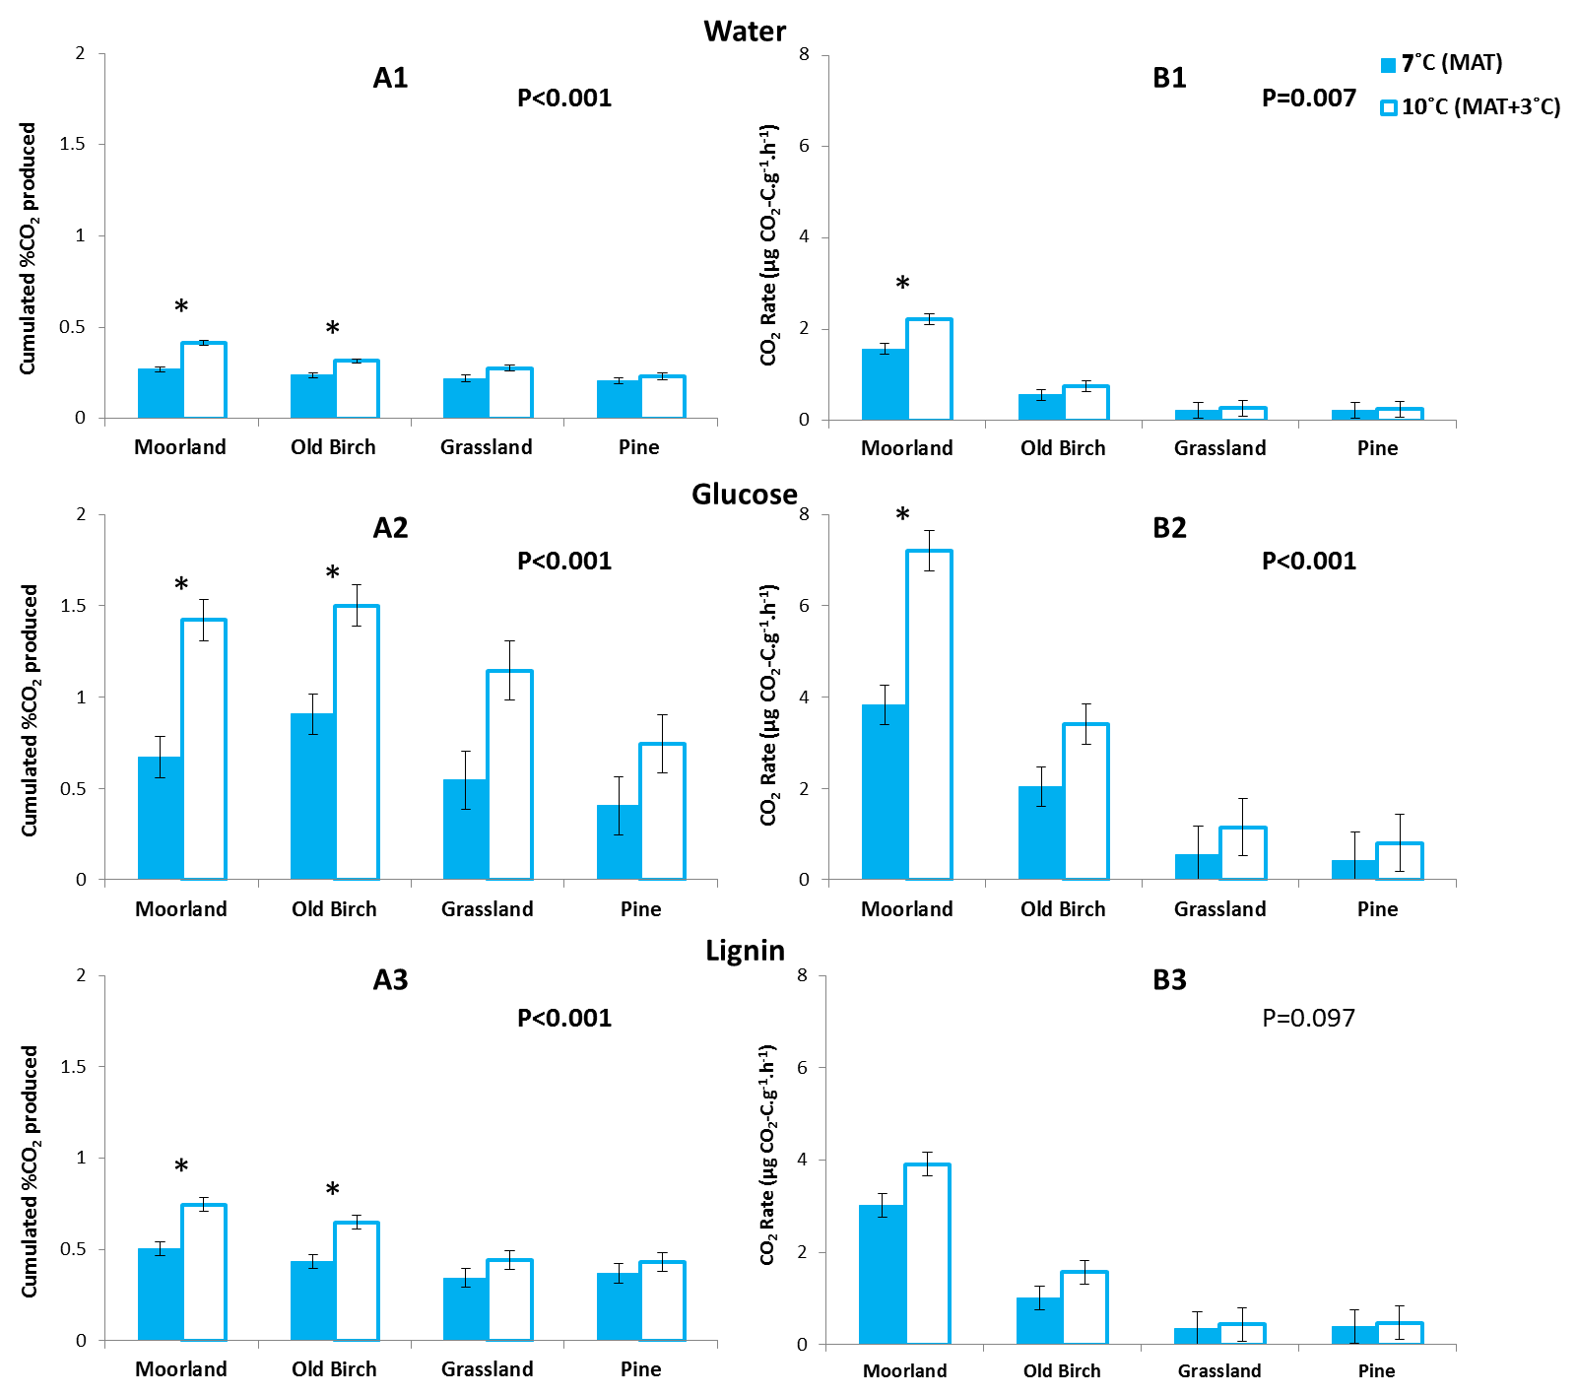
Supplementary Figure 2: Effect of land use and temperature on soil respiration after 24h of incubation.
For each carbon source/substrate (water (1), glucose (2) and lignin (3)), data represent the predicted means (n=8 for Moorland and Old Birch; n=4 for Grassland and Pine) and P values obtained from LMM analysis. Graphs labelled (A) show the cumulated percentage of CO₂ produced, while the graphs labelled (B) show the calculated CO₂ rates. Error bars represent standard deviations. The asterisks show the treatments for which a significant difference was detected by the post-hoc test (Bonferroni procedure – α<0.05).

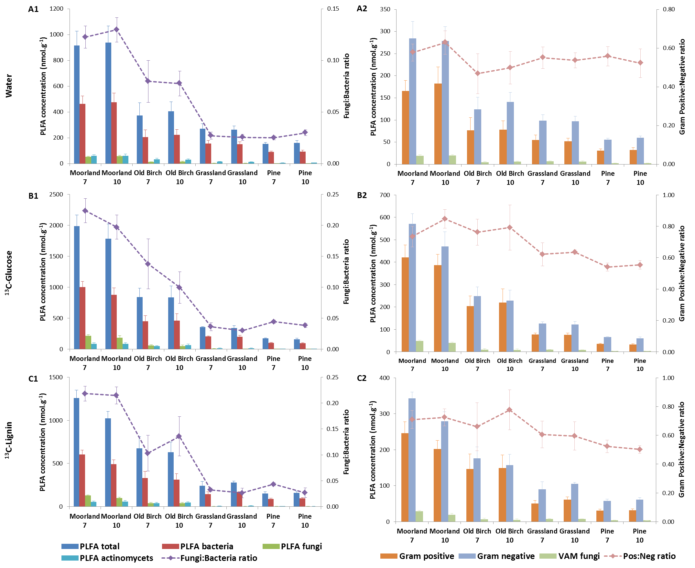
Supplementary Figure 3: Microbial biomass in soils after incubation with no substrate (A), ¹³C-glucose (B) and ¹³C-lignin (C) under MAT (7°C) and MAT+3°C (10°C).
Data represent PLFA means (error bars are s.e.m.) (n=8 for Moorland and Old Birch; n=4 for Grassland and Pine) of different microbial groups. The significance tests for each PLFA group are presented in Supplementary Table 7. Graphs labelled (1) show the cumulated percentage of CO₂ produced, while the graphs labelled (2) show the calculated CO₂ rates.

Supplementary Table 6: Significance tests of the effect of land use, carbon source and temperature on soil microbial composition after five days of incubation.
For each CV axis, data represent the P values obtained from the nested LMM test performed on the CV scores from the PC scores of the PLFA abundance data (see Figure 5 of main text). The letters (a through h) show the treatments with significant difference (P values in bold) according to pairwise comparison following the Bonferroni procedure as post-hoc test (α<0.05). The mean separation for the last level of interaction (Land use/Carbon Source/Temperature) is not displayed as no statistical significance was detected.
 |  | CV-1 | CV-2
Land use |  | <0.001 | <0.001
Land use/Carbon Source |  | <0.001 | <0.001
Land use/Carbon Source/Temperature |  | 0.818 | 0.346
Land use | Moorland | c | c
Land use | Old Birch | b | b
Land use | Grassland | a | a
Land use | Pine | a | a
Land use/Carbon Source | Moorland – No substrate | d | d
Land use/Carbon Source | Old Birch – No substrate | a | e
Land use/Carbon Source | Grassland – No substrate | a | abc
Land use/Carbon Source | Pine – No substrate | a | abc
Land use/Carbon Source | Moorland – ¹³C-glucose | e | d
Land use/Carbon Source | Old Birch – ¹³C-glucose | bcd | e
Land use/Carbon Source | Grassland – ¹³C-glucose | abc | abc
Land use/Carbon Source | Pine – ¹³C-glucose | a | abc
Land use/Carbon Source | Moorland – ¹³C-lignin | e | bc
Land use/Carbon Source | Old Birch – ¹³C-lignin | cd | c
Land use/Carbon Source | Grassland – ¹³C-lignin | ab | ab
Land use/Carbon Source | Pine – ¹³C-lignin | a | a
Variation explained |  | 52.6% | 31.3%

Supplementary Table 7: Significance tests of the effect of land use, carbon source and temperature on PLFA abundance after five days of incubation.
For each category of PLFA, data represent the P values obtained from the nested LMM test. The letters (a, b, c) show the treatments with significant difference (P values in bold) according to pairwise comparison following the Bonferroni procedure as post-hoc test (α<0.05). The mean separation for the last level of interaction (Land use/Carbon Source/Temperature) is not displayed as no statistical significance was detected.
 |  | Total PLFA | PLFA Bacteria | PLFA Fungi | Fungi:Bacteria ratio | PLFA Actinobacteria | Gram Positive | Gram Negative | Gram Pos:Neg ratio
Land use |  | <0.001 | <0.001 | <0.001 | <0.001 | <0.001 | <0.001 | <0.001 | 0.025
Land use/Carbon Source |  | <0.001 | <0.001 | <0.001 | 0.028 | 0.111 | <0.001 | <0.001 | 0.020
Land use/Carbon Source/Temperature |  | 0.987 | 0.988 | 0.896 | 0.959 | 1.000 | 1.000 | 0.795 | 0.999
Land use | Moorland | c | c | c | c | c | c | c | b
Land use | Old Birch | b | b | b | b | b | b | b | ab
Land use | Grassland | a | a | a | a | a | a | a | ab
Land use | Pine | a | a | a | a | a | a | a | a
Land use/Carbon Source | Moorland – No substrate | ef | bde | c | cd | cd | bcde | c | ab
Land use/Carbon Source | Old Birch – No substrate | abcd | abc | abc | abc | abc | abcde | ab | a
Land use/Carbon Source | Grassland – No substrate | ab | a | abc | a | ab | ab | a | ab
Land use/Carbon Source | Pine – No substrate | a | a | a | a | a | ab | a | ab
Land use/Carbon Source | Moorland – ¹³C-glucose | g | f | e | de | d | f | d | b
Land use/Carbon Source | Old Birch – ¹³C-glucose | cef | bde | bc | bc | bcd | ce | bc | b
Land use/Carbon Source | Grassland – ¹³C-glucose | abc | ab | abc | ab | ab | abc | ab | ab
Land use/Carbon Source | Pine – ¹³C-glucose | ab | a | abc | ab | a | ab | a | ab
Land use/Carbon Source | Moorland – ¹³C- lignin | f | e | d | e | bcd | e | c | ab
Land use/Carbon Source | Old Birch – ¹³C- lignin | bcde | abcd | abc | bc | abc | abcd | ab | ab
Land use/Carbon Source | Grassland – ¹³C- lignin | ab | a | abc | ab | a | ab | a | ab
Land use/Carbon Source | Pine – ¹³C- lignin | a | a | ab | a | a | a | a | ab

Supplementary Table 8: Significance tests of the effect of land use on the microbial community structure after incubation with water, ¹³C-glucose and ¹³C-lignin under MAT (7°C) and MAT+3°C (10°C).
For each microbial group, data represent the P values obtained from the nested LMM test performed on the CV scores from the PC scores of the MT-RFLP data (see Figure 6 of main text). The letters (a through f) show the treatments with significant difference (P values in bold) according to pairwise comparison following the Bonferroni procedure as post-hoc test (α<0.05). The mean separation for the last level of interaction (Land use/Carbon Source/Temperature) is not displayed as no statistical significance was detected.
 |  | Fungi |  | Bacteria |  | Archaea
 |  | CV-1 | CV-2 | CV-1 | CV-2 | CV-1 | CV-2
Land use |  | <0.001 | <0.001 | <0.001 | <0.001 | <0.001 | <0.001
Land use/Carbon Source |  | <0.001 | <0.001 | 0.844 | 0.313 | 0.856 | 0.001
Land use/Carbon Source/Temperature |  | 0.661 | 0.994 | 0.780 | 0.793 | 0.531 | 0.162
Land use | Moorland | a | a | a | b | a | b
Land use | Old Birch | b | b | a | a | a | b
Land use | Grassland | c | a | c | a | b | a
Land use | Pine | c | a | b | b | c | b
Land use/Carbon Source | Moorland – No substrate | a | a | a | bcd | a | bcd
Land use/Carbon Source | Old Birch – No substrate | bc | c | a | abcd | a | bc
Land use/Carbon Source | Grassland – No substrate | de | ab | c | abcd | b | ab
Land use/Carbon Source | Pine – No substrate | def | a | b | bcd | b | d
Land use/Carbon Source | Moorland – ¹³C-glucose | ab | a | a | bcd | a | bcd
Land use/Carbon Source | Old Birch – ¹³C-glucose | cd | b | a | abc | a | bc
Land use/Carbon Source | Grassland – ¹³C-glucose | f | ab | c | ab | b | a
Land use/Carbon Source | Pine – ¹³C-glucose | ef | ab | b | bcd | b | abc
Land use/Carbon Source | Moorland – ¹³C-lignin | ab | ab | a | bcd | a | bcd
Land use/Carbon Source | Old Birch – ¹³C-lignin | c | c | a | a | a | bcd
Land use/Carbon Source | Grassland – ¹³C-lignin | def | a | c | abcd | b | ab
Land use/Carbon Source | Pine – ¹³C-lignin | def | ab | b | bd | b | cd
Variation explained |  | 49.5% | 30.5% | 77.7% | 8.0% | 71.6% | 16.7%

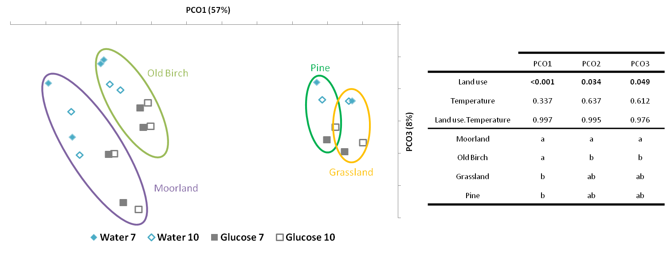
Supplementary Figure 4: Microbial community structure under different land uses, and after incubation without substrate and with ¹³C-glucose, based on weighed UniFrac analysis of 16S rRNA genes (pyrosequencing).
Data represent the scores from the principal coordinate analysis (PCoA) of the pooled triplicate samples. Although the second axis (PCO2) accounts for more variation (18%), the use of PCO3 allows for a better separation of the treatments when paired with PCO1. The circles do not represent any statistical difference between treatments. They were added for clarity only. Because pooled samples were used, no statistical analysis could be performed on the effect of ¹³C-glucose addition. The ordination would suggest that the addition of ¹³C-glucose seemed to induce a microbial shift associated with land-use change. By using the C sources as replicates (giving n=8 for the soils from the Moorland/Old Birch sites (Craggan and Tulchan) and n=4 for the soils from the Grassland/Pine site (Glensaugh)), the effect of land use and temperature could be investigated (see table above). Land-use change had an effect on the soil bacterial community structure when birch trees colonised moorland. Elevated temperature did not have an effect on any of the land use types, which is congruent with the PLFA and T-RFLP analyses. The table contains the significance tests of the effect of land use and temperature on soil microbial composition. The P values were obtained from the LMM test performed on the PCO scores. The letters (a and b) show the treatments with significant difference (P values in bold) according to pairwise comparison following Bonferroni procedure as post-hoc test (α<0.05).

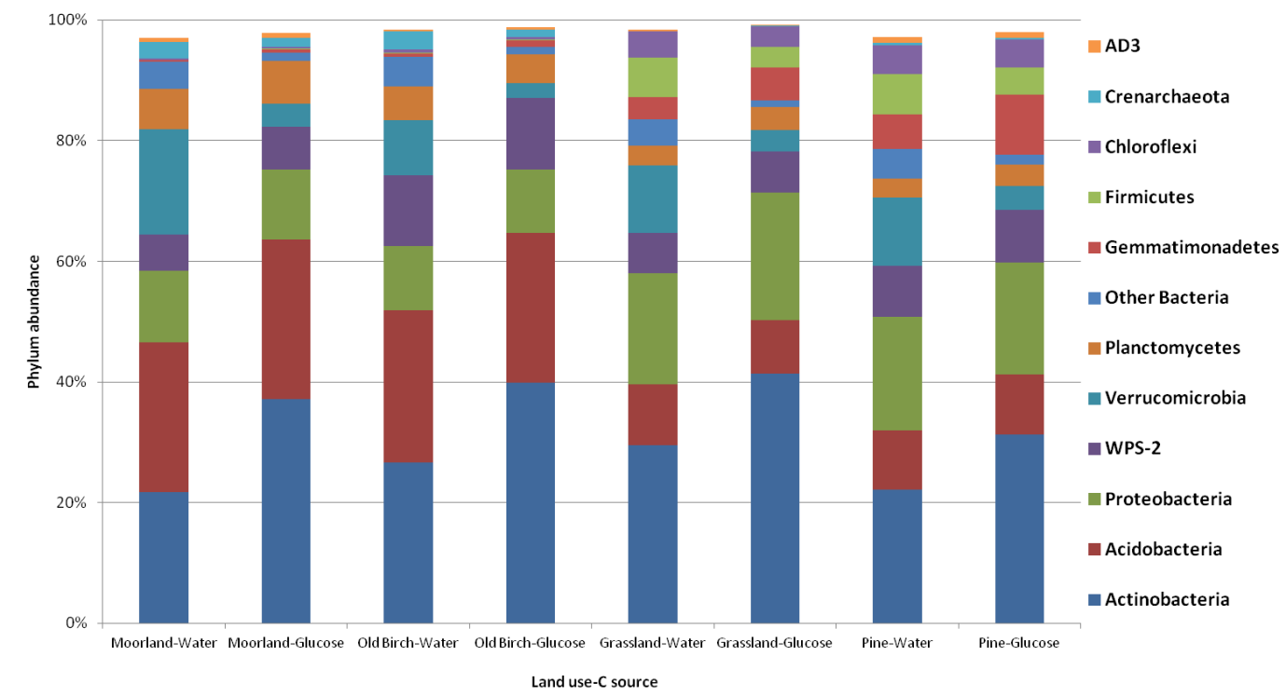
Supplementary Figure 5: Most abundant phyla of microorganisms detected in the soils under different land uses after a 5-day incubation period with water and ¹³C-glucose.
Data represent the percentage presence of a particular phylum (pooled replicates). Only phyla that constituted >0.5% of the total phylum abundance were included in the analysis, representing ~98% of phylum presence in all samples.

References
Burnham,K.P., Anderson,D.R., 2002. Model selection and multimodel inference: a practical information-theoretic approach. Springer.
Symonds,M.R., Moussalli,A., 2011. A brief guide to model selection, multimodel inference and model averaging in behavioural ecology using Akaike's information criterion. Behavioral Ecology and Sociobiology 65, 13-21.

